**Phonics**

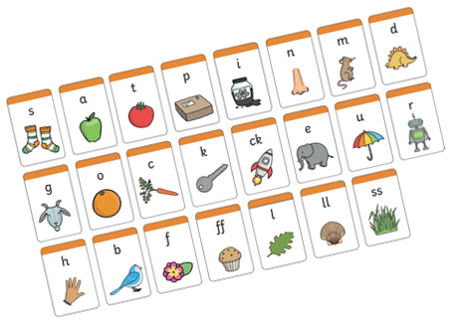Children are taught to read by breaking down (segmenting) words into separate sounds or ‘phonemes’. They are then taught how to blend these sounds together to read the whole word.

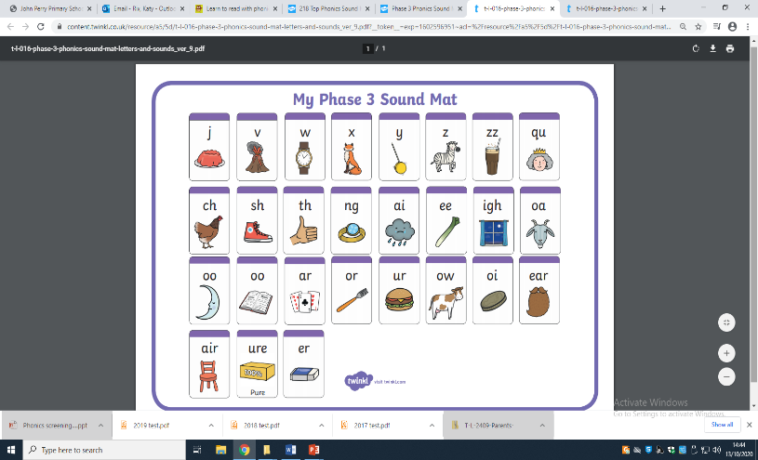

Children in Key Stage 1 have regular phonics lessons all through the week and they are encouraged to use these strategies to read and write in other lessons.

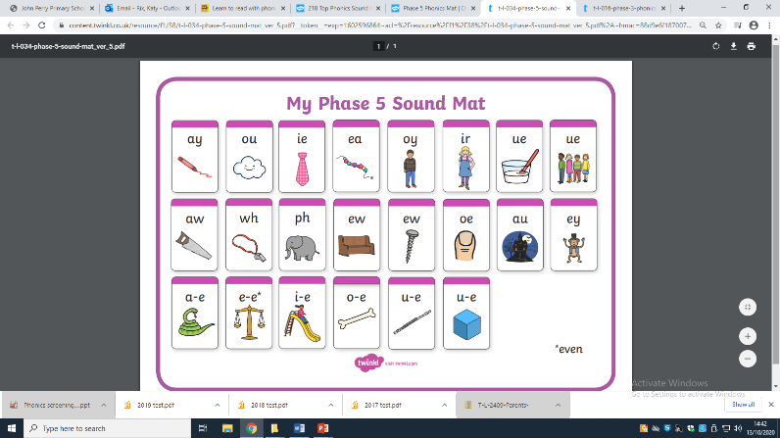

**Phonics Screening**

The Phonics Screening Check is designed to confirm whether individual children have learnt phonic decoding (i.e. apply their knowledge of letter-sound relationships) and blending (i.e. the skill of joining individual speech sounds (phonemes) together to make a word) skills to an appropriate standard

* 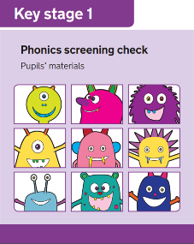 This ‘mid-point’ check will allow teachers to ensure that any gaps in children’s knowledge is filled by the end of Year 2.

**What do we expect the children to do?**

* The check is very similar to tasks the children already complete during phonics lessons.
* Children will be asked to ‘sound out’ a word and blend the sounds together, eg d-o-g – dog.

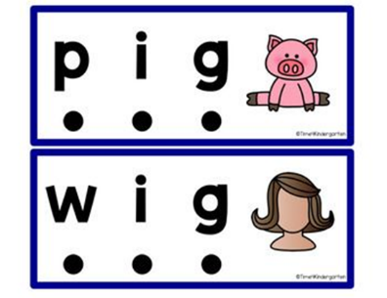

* The children will have to read a mixture of 20 Real words and 20 Alien words using previously taught sounds.

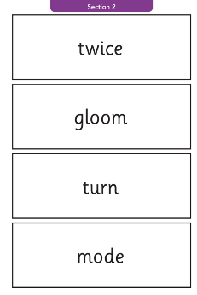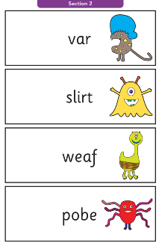Alien Words Real Words

* The focus of the check is to see which sounds the children know.

**IT IS NOT A READING TEST**

**How can you help?**

The way in which you learnt to read, is probably very different from the way we teach children to read now, so here is a quick guide to some of the things you can do to help your child in preparation for the Screening Check.

1. **Remind your child to look for the following when faced with an unfamiliar word (real or alien/pseudo)** 
   * Look for any familiar digraphs first, then any trigraphs, then any split digraphs. Whatever is left are single phonemes.
2. **Encourage children to use sound buttons when breaking the words down.**

* 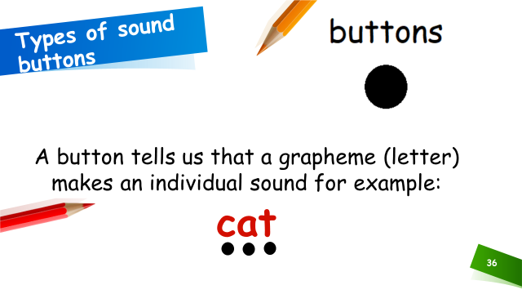A dot or button for a single phoneme
* 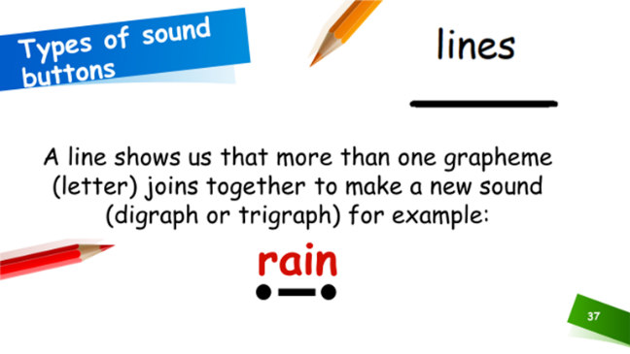A small line or zip for a digraph/trigraph zip
* A hook for a split digraph.

hook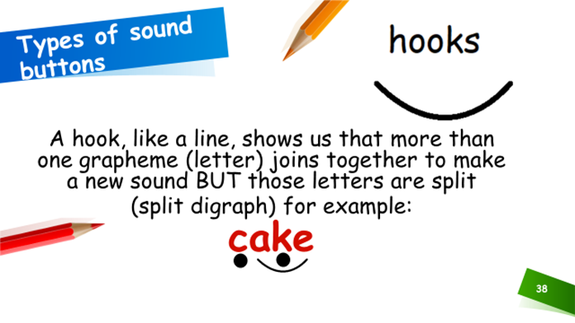

These should all be placed under the letters in the word.

1. **Play some online game**

**Here are some links to helpful website that give more information on the teaching of Phonics:**

* **Little Wandle – parent videos**

[**For parents | Letters and Sounds (littlewandlelettersandsounds.org.uk)**](https://www.littlewandlelettersandsounds.org.uk/resources/for-parents/)

* **Oxford Owl**

[**https://home.oxfordowl.co.uk/reading/learn-to-read-phonics/**](https://home.oxfordowl.co.uk/reading/learn-to-read-phonics/)

* **Phonics Play:**

[**https://www.phonicsplay.co.uk/InteractiveResources.htm**](https://www.phonicsplay.co.uk/InteractiveResources.htm)

* **YouTube – phoneme pronunciation:**

[**https://www.youtube.com/watch?time_continue=18&v=UCI2mu7URBc&feature=emb_logo**](https://www.youtube.com/watch?time_continue=18&v=UCI2mu7URBc&feature=emb_logo)

**Thank you for your ongoing support.**