My history learning journey:
History units I have studied:
Reception | Important people in our lives  - Our families | Why do we celebrate?  - Diwali  - Eid  - Christmas  - Bonfire Night  - Lunar New Year | Famous explorers  - Charles Darwin  - Henry Bates  - Ernest Shackleton
Year 1 | Toys in the past-Rags to Riches  - Victorian dolls  - Artefact handling  - Changes in toys | Moon landing and space-To infinity and beyond  - Space launches  - Moon landing and Neil Armstrong  - British space travel and Tim Peake | The Seaside-Sea holidays past and present  - Queen Victoria  - Brighton in Victorian era and today  - Fashion-costumes
Year 2 | Transport-Wheels and wings  - Changes in bikes, cars, trains and aeroplanes  - The Wright brothers  - Amelia Earhart | The Great Fire of London  - Tudor housing  - Puddling lane  - Samuel Pepys | Homes of the past  - Changes in houses over decades  - Technology and inventions used in homes  - Artefact handling
Year 3 | Anglo-Saxons, Picts and Scots  - Settlement and housing  - Daily life through artefact handling  - Sutton Hoo |  | Ancient Egypt  - Pharaohs and slaves  - Gods/Goddess  - Pyramids  - Inventions and achievements
Year 4 | Romans  - Empire and emperors  - Daily life  - Gladiators  - Gods/Goddess |  | Saxons to Vikings  - Invasions and Lindisfarne  - Danelaw and settlements  - King Alfred the Great  - Daily life
Year 5 | Stone Age to Iron Age  - Skara Brae  - Hunter gathers and weapons  - Artefact handling | The Victorians  - Queen Victoria  - Industrial Revolution  - School life  - Medicine and inventions | Ancient Greeks  - Democracy  - Gods  - Philosophers  - Olympics
Year 6 | WW2-Battle of Britain  - Evacuation  - The Blitz  - Rationing  - Holocaust |  | The Mayans  - Religion and beliefs  - City states and civilisation  - Mayan life, writing and calendars  - Houses and settlement
Timeline of history
Dinosaurs Stone Age Ancient Egypt Ancient Greece Romans
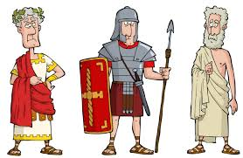
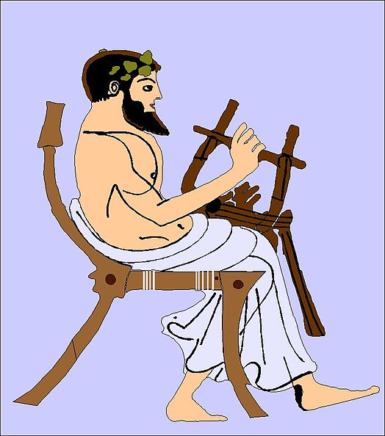
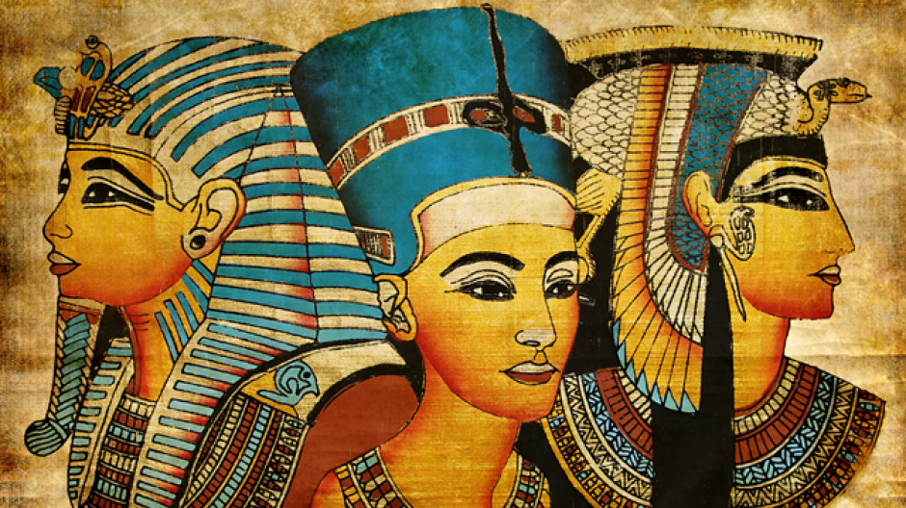
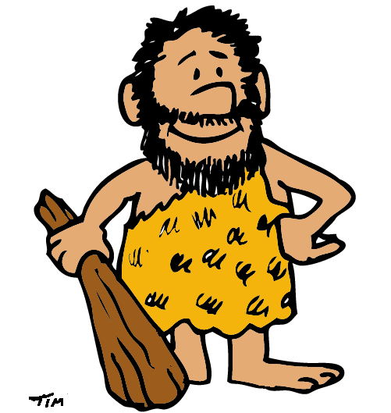
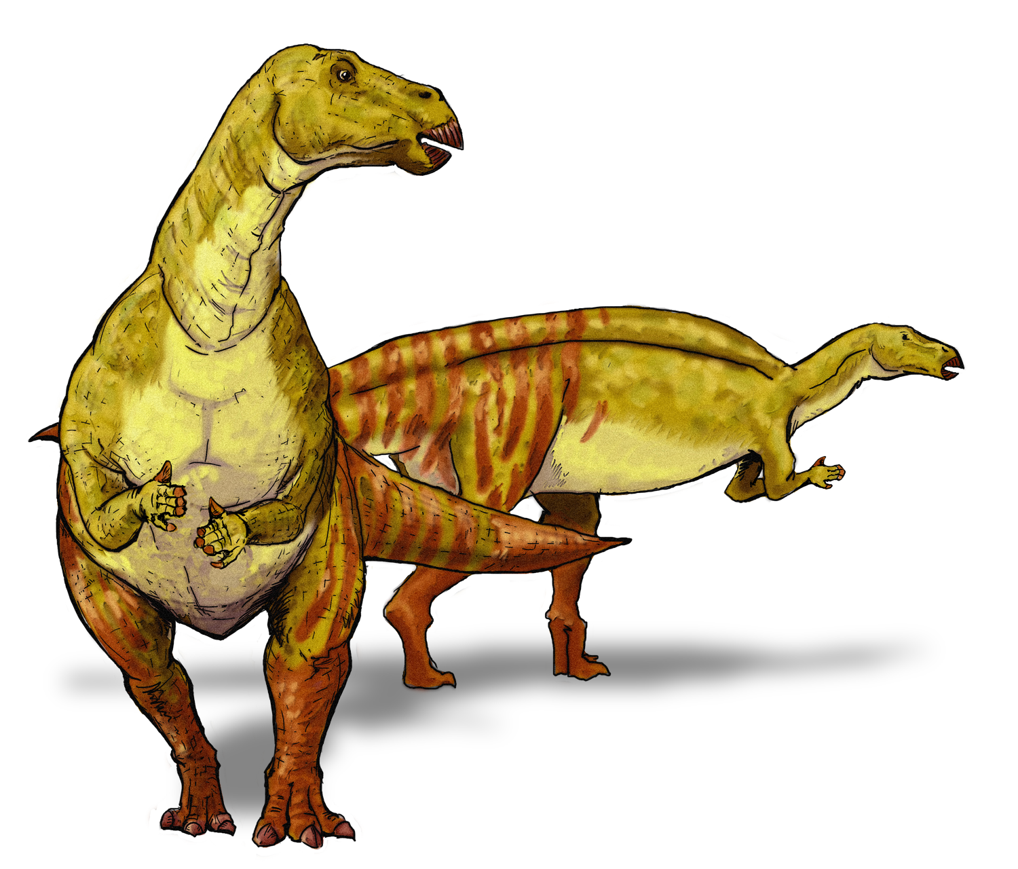
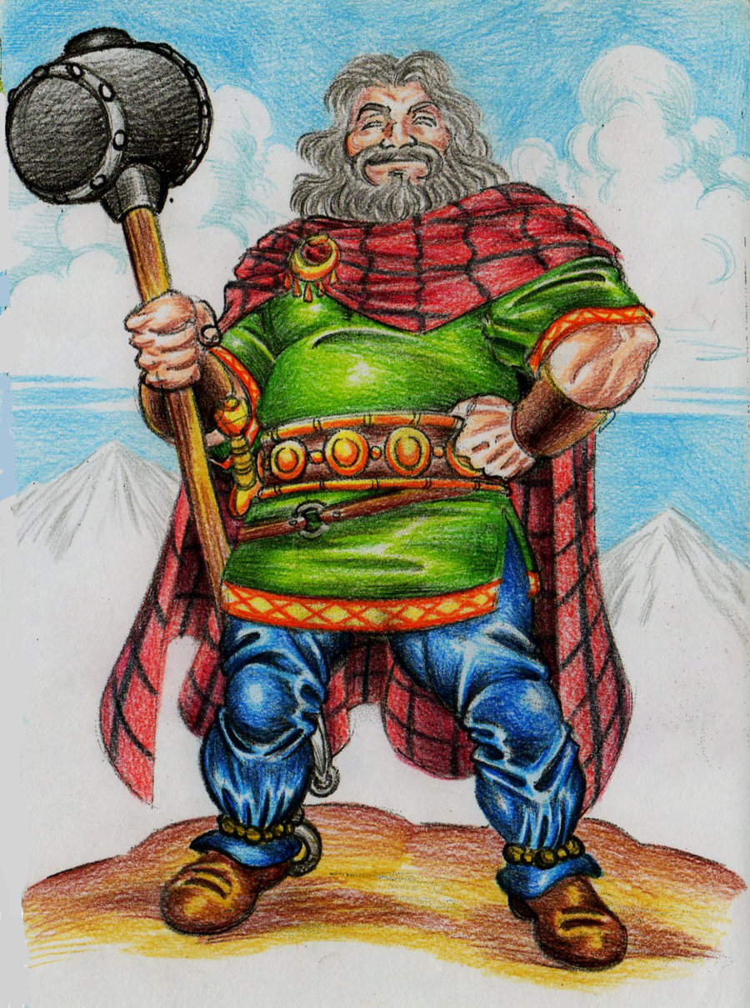

4500 BC – 332 BC
200,000 years ago -6,000 years ago
600BC – 476AD
800 BC – 146 BC
245 Million years ago -
65 Million years ago
600 BC – 50AD

This Photo by Unknown Author is licensed under CC BY-SA
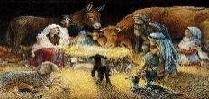
0 Jesus is born
Anglo Saxons Vikings Normans Tudors Great Fire of London Victorians WW I WWII
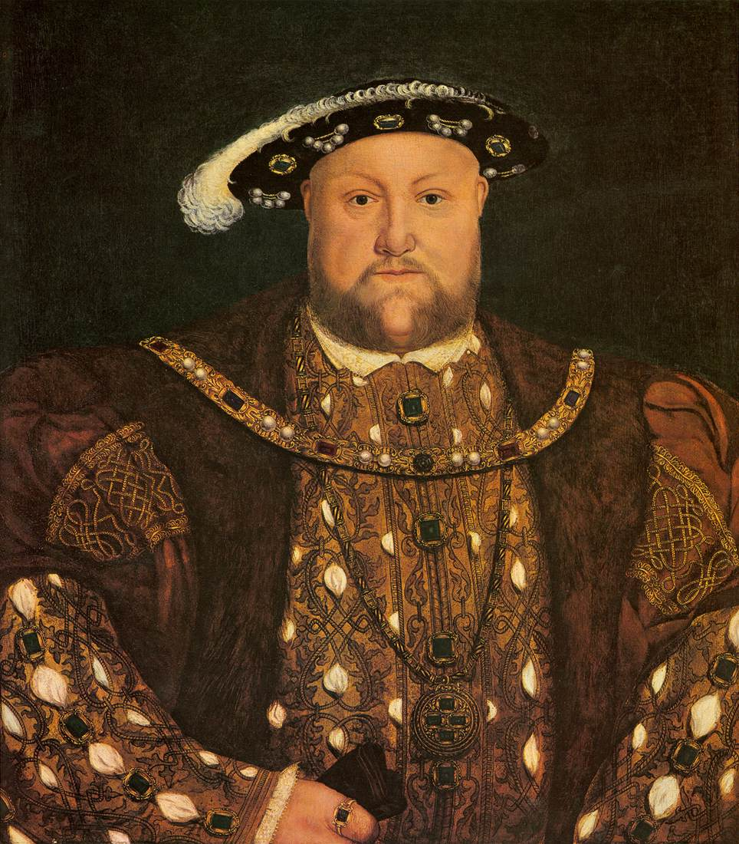
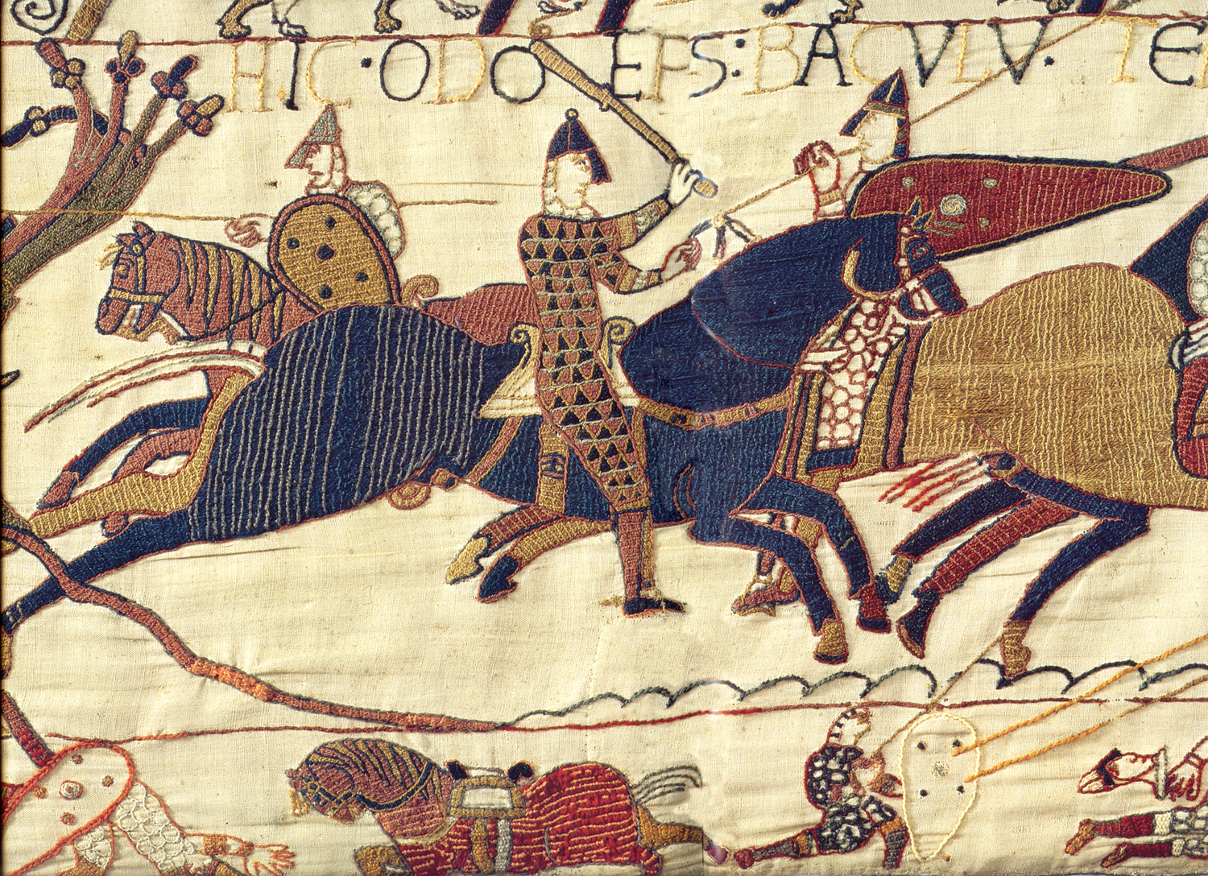
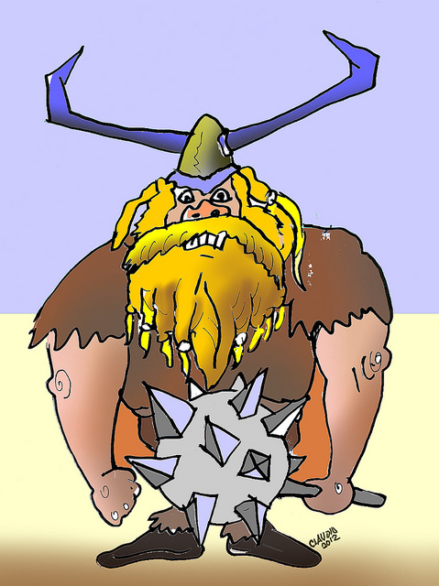
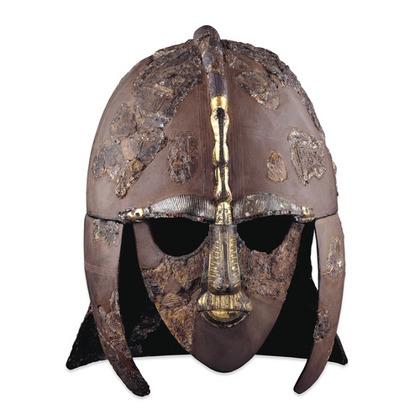
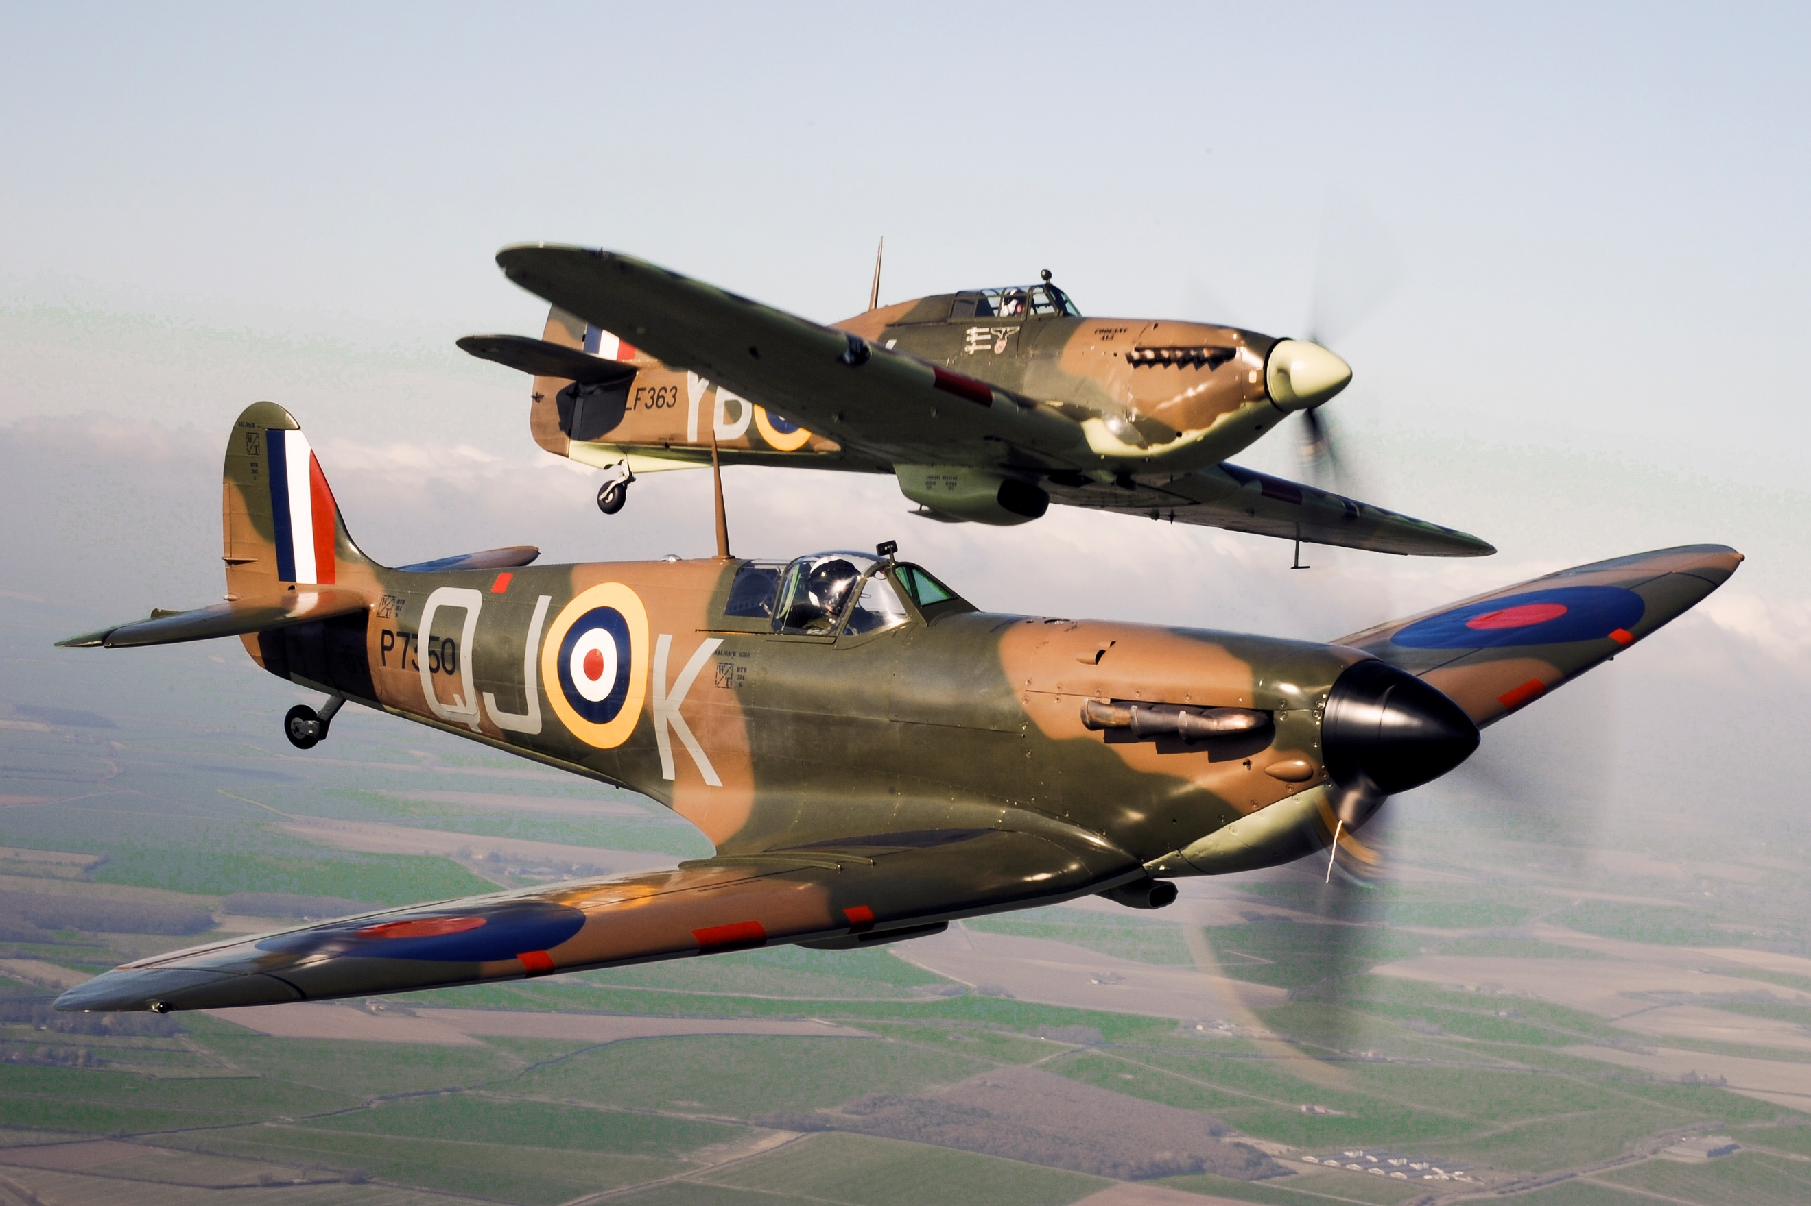
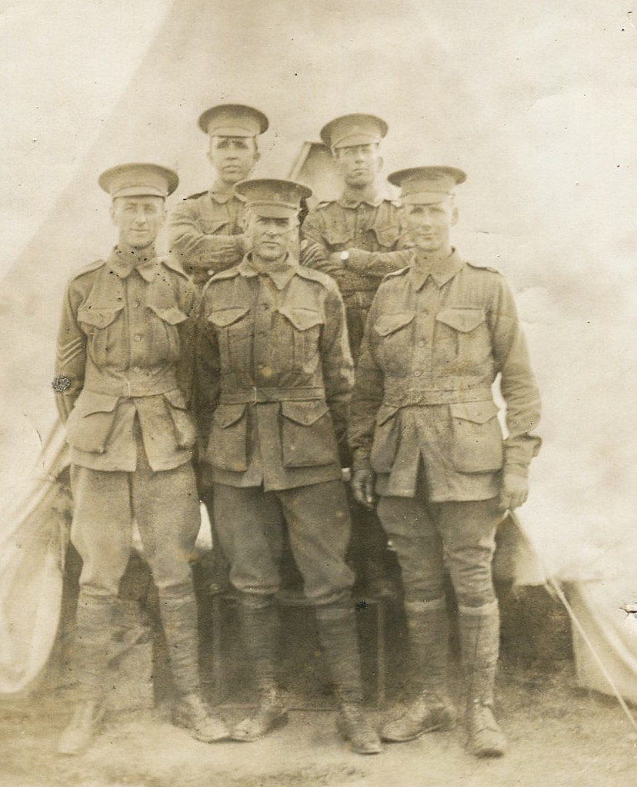
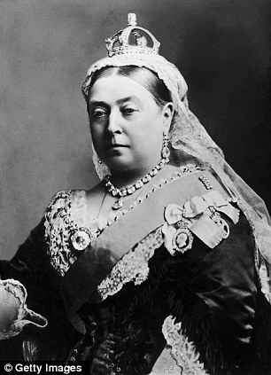
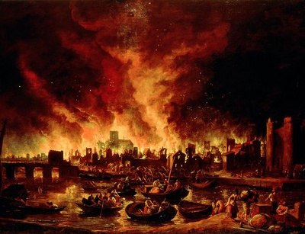

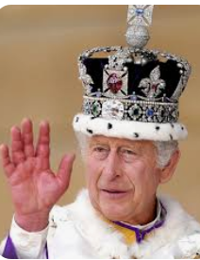
1837 -1901
1666
750 - 1060
1939 -1945
1914 - 1918

1485 -1603
1066
410 -1066
Present Day

2024
1939 -1945

